Sports Trends Conclusions

My goal is to identify the most popular professional sports league in the world. I am going to compare the Premier League, the NFL, the NBA and the MLB. I am examining the data from Google Trends and the Twitter API. Twitter averages more than 500 millions tweets per day and Google averages approximately 8.5 billion searches per day.[1][2]

After conducting the ANOVA test, it was revealed that the p value for the twitter data is .01 and therefore there are significant differences in the tweet counts per league. As a result, we can conclude that based on the amount of tweets referencing their team and league accounts, the Premier League and NFL are the most discussed sports leagues in the world. This supports my hypothesis that there would be noticeable differences between the leagues. The TTest comparing the NFL and Premier League suggests there is not a significant difference between them, however the NFL is not in season and would have more tweets if it were.

The Google Trends data from the past week reveals different rankings than the Twitter data. Google ranks the NBA as the clear leader, with the NFL in second, the Premier League in third and the MLB in fourth. The Google Trend data from the past year ranked the sports leagues the same as the Google Trend Data from the past week, with similar proportions in the pie chart.

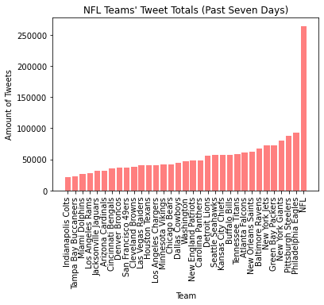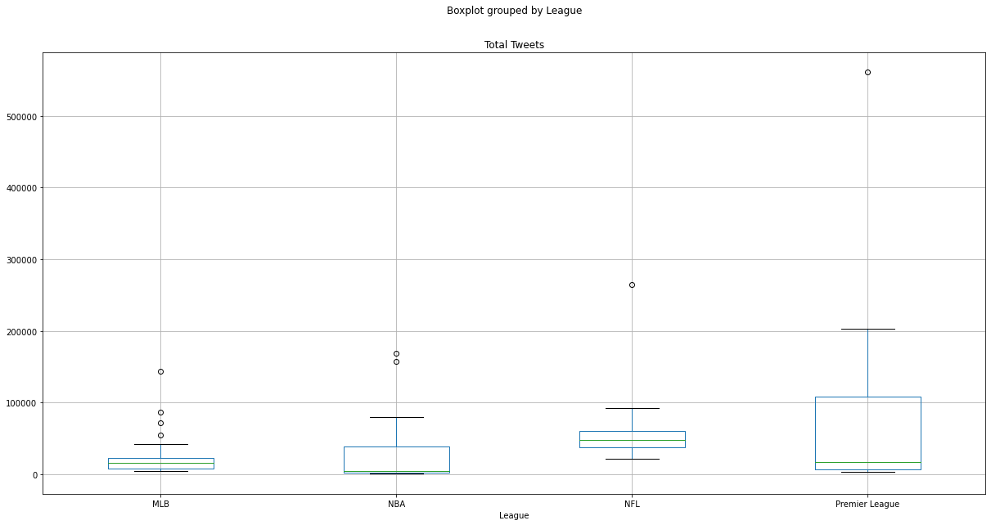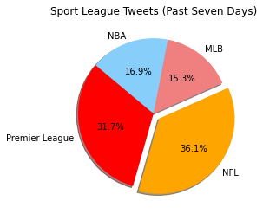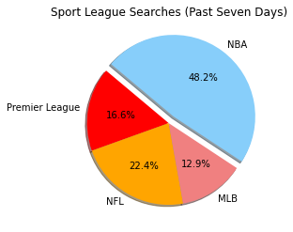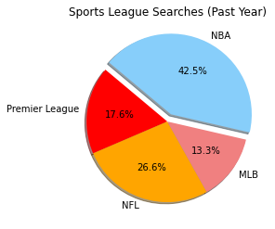

1. Claire Beveridge, 33 Twitter Stats That Matter to Marketers in 2022, <https://blog.hootsuite.com/twitter-statistics/>
2. Maryam Mohsin, 10 Google Search Statistics You Need to Know in 2022, <https://www.oberlo.com/blog/google-search-statistics>